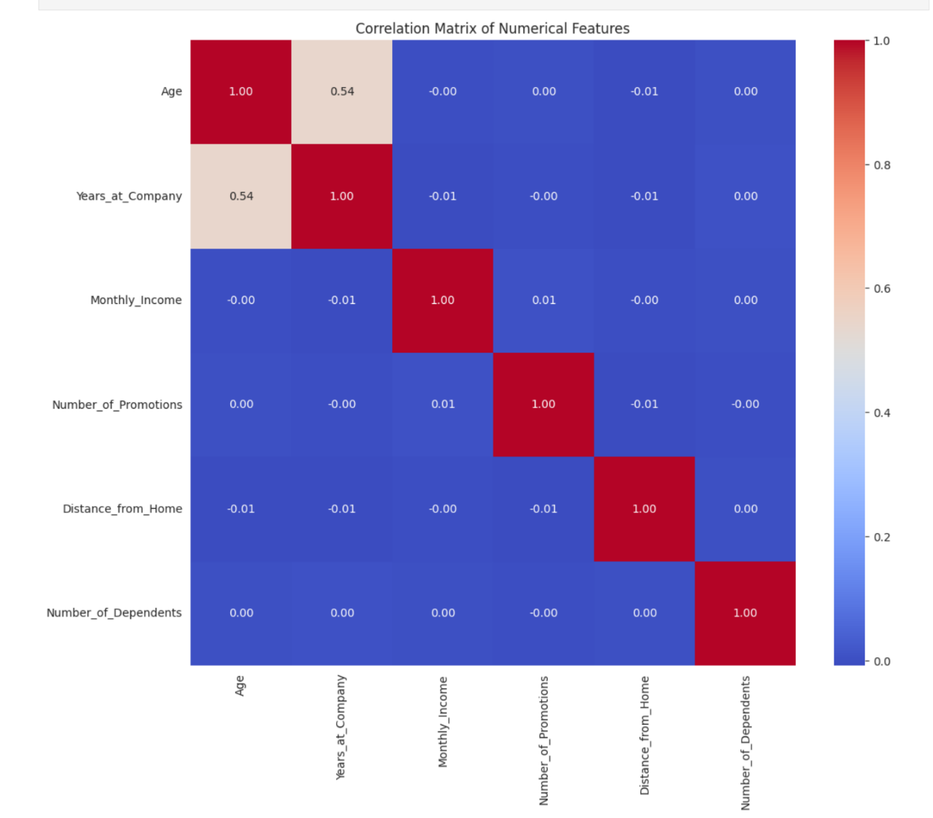  
  
The correlation matrix reveals a moderate positive correlation (0.54) between age and years at the company, suggesting that as employees age, they tend to have longer tenures at the company. Other variables such as monthly income, number of promotions, distance from home, and number of dependents show very little to no correlation with each other, indicating their effects are largely independent within this dataset  
  
Job Role in Finance and Attrition: There is a negative correlation (-0.24) between being in a finance role and attrition, suggesting that employees in finance are less likely to leave, possibly due to better job satisfaction or higher barriers to exit compared to other fields.

A positive correlation (0.22) indicates that larger companies are more likely to offer remote working options, which might be due to their greater resources and more flexible work policies.

1. **Job Level and Remote Work Influence**  
   ✔️ **Matches**: The left-most subtree shows that employees with Job_Level <= 1.5 and Remote_Work <= 0.5 lean toward **class 1** (staying). However, your value [10817.0, 136851.0] seems to have a typo — it should be [10817, 13851].
2. **Marital Status and Remote Work Influence**  
   ✔️ **Matches**: For Marital_Status_Single > 0.5 and Job_Level <= 1.5, then Remote_Work <= 0.5, the class leans toward **class 0** (leaving) — which is correctly interpreted in your rule with values [9910, 3497].
3. **Age and Job Level Influence**  
   ✔️ **Matches**: In the far left of the right subtree, when Age <= -1.164, the values [15, 1198] show strong class 1 dominance — consistent with your interpretation.
4. **Work-Life Balance Influence**  
   ✔️ **Matches**: The rightmost node shows Work-Life_Balance > 2.5 leading to [69, 536] — a strong Class 1 indicator. Your rule is correct.
5. **Gender and Job Level Influence**  
   ✔️ **Matches**: In the left subtree, when Job_Level <= 1.5 and Gender <= 0.5, the values [709, 4409] confirm the likelihood of staying — just as you wrote.